Mobile App Prototype

David Graves
Colorado State University Global
CSC505
Dr. Steven Evans
January 27, 2025

Designing an application
Application developers have many tools at their disposal when designing products for end users. Many of the questions that are explored and answered early in the project development lifecycle can help a developer understand the best tools to fit the purpose for design. Critical architecture questions and requirements gathering involving the project team and customer can provide key insight into standing up a model for a successful project. Once some of the fundamental project model groundwork has been laid, developers typically construct a prototype as an early step to help guide future work. As a developer this prototype can help, “…you and other stakeholders to better understand what is to be built when requirements are fuzzy.” (Pressman & Maxim, 2020, page 26) For the sake of exploring this early project work in greater detail to better understand the power of a prototype, imagine I have been contacted to develop a ‘first’ prototype for a mobile shopping list ap. I’ll use the remainder of this paper to walk through creating a preliminary architectural design all the way through writing a script in Python that shows the expected prototype application experience including the names and number of pages as well as the sequence and flow of the pages.
Prototype Design
One of the first steps a developer takes prior to writing actual script is to sketch a design of the prototype application that will fit the customer requirements. A Unified Model Language (UML) diagram is a great tool for doing just that. There are many different types of UML diagrams that mainly sit under two different parent categories, “Structural” and “Behavioral” Diagrams. To build the prototype for my shopping list application I chose the “Activity” diagram which is one of the behavioral diagrams. This one should work well because, “Activity diagram(s) represent workflows in a graphical way” (Nishadha, Jan 6, 2025, Paragraph 15).
Another benefit to using UML to show a mock-up for a prototype is it allows others within the project team to physically get a view of what I’m thinking, and it can be measured against requirements prior to putting the effort into the actual coding work. A reasonable preliminary architectural design for the prototype that can be brought to the project team is shared in Image 1 below.
Image 1 (UML Prototype)
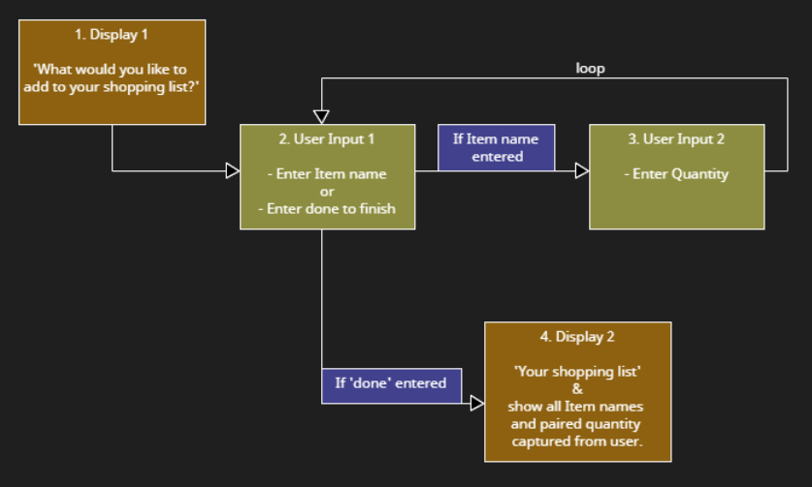
Since “gathering feedback is a crucial element in the design thinking process” (Dam & Siang, n.d., Paragraph 1), doing that in a structured manner will help me understand if I am on the right track with my design choices. Some of the key steps Dam and Siang offer as part of the feedback process include thinking of how to solicit feedback, testing your prototype on the right people, and adapting while you test. Armed with customer and project team feedback now, I can start writing the script for my shopping list application prototype.
The first set of code (Image 2) I wrote as an example explains the expected flow of the pages sketched in the UML Prototype. One of the challenges I experienced when writing this script was whether to somehow include the flow or sequence as part of the actual code output or to share it via ‘print’ including freeform notes. As the reader can see, I opted for a little bit of both with the intent to provide clarity regarding what steps follow a user’s specific input activity. It’s not the most elegant code in my opinion, but the output as shown in Image 3 is clean and fairly represents the UML sketch.
Image 2 (Python Program)
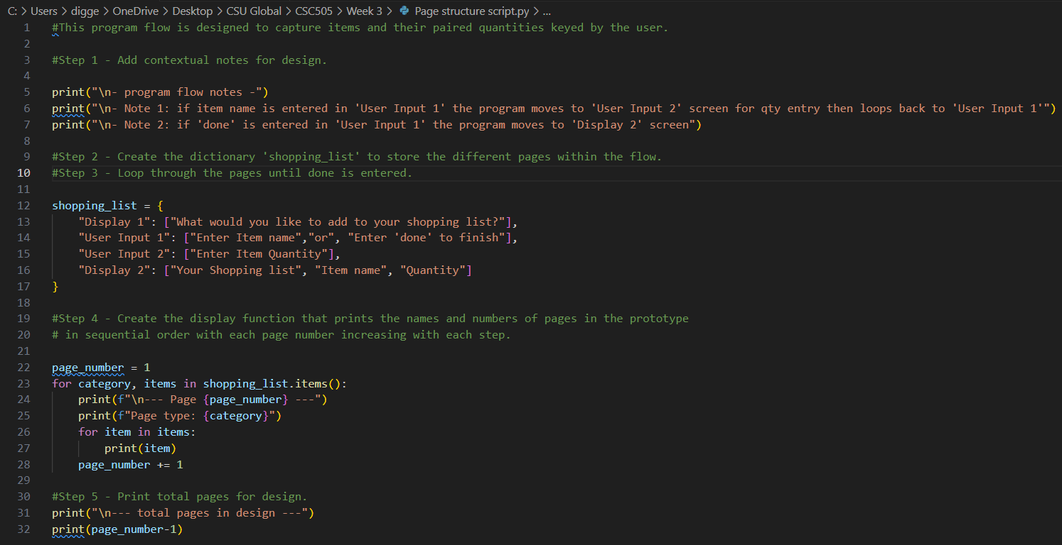

Image 3 (Terminal Output)
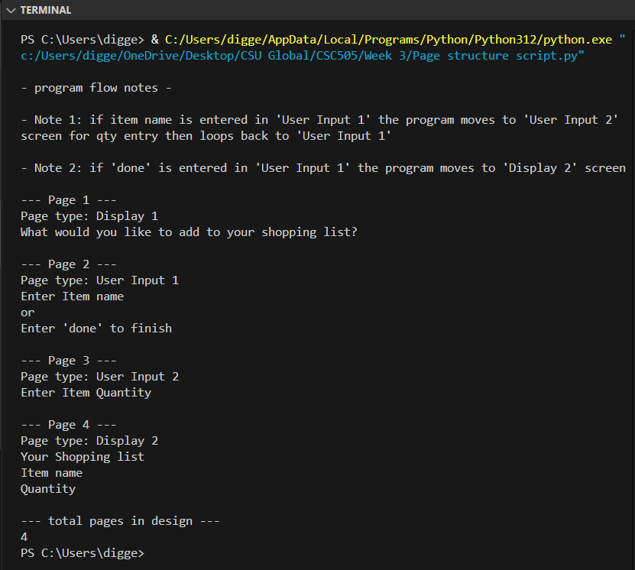
After completing the script showing the expected flow based off the UML, I was curious what an actual prototype might look like and decided to attempt writing a “first” version as shared in Image 4 and its output in Image 5. I realize this is not part of the exercise but found this additional exercise rewarding and worth the time and effort.

Image 4
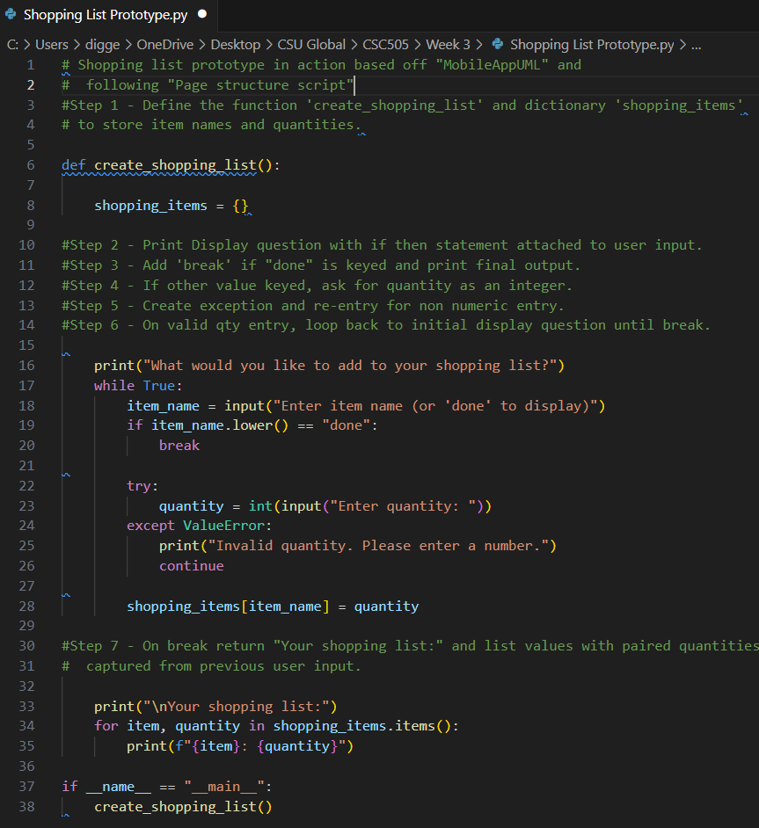
Image 5
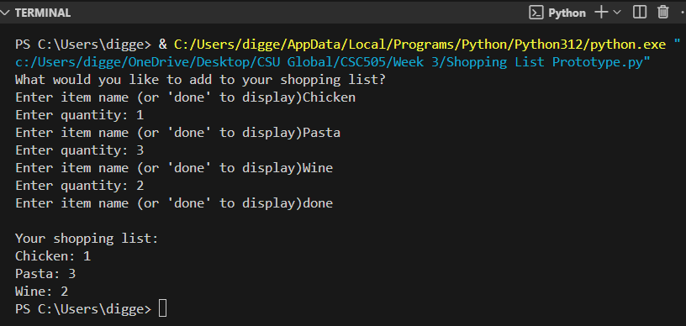
References
Dam, Rikke Friis & Siang, Teo Yu (n.d.). Interaction-design.org. Test Your Prototypes: How to
Gather Feedback and Maximize Learning.
https://www.interaction-design.org/literature/article/test-your-prototypes-how-to-gather-feedback-and-maximise-learning?srsltid=AfmBOooIaoyb3tjd3E5ktCFC3gd0Q-gQ-jUOUA_e9B34rUVwsnEKnJjD
Nishadha (2025, Jan 6). Creately.com. UML Diagram Types Guide: Learn About All Types
of UML Diagrams with Examples.
https://creately.com/blog/diagrams/uml-diagram-types-examples/
Pressman, R. S., & Maxim, B. R. (n.d.). Software Engineering: A Practitioner’s Approach.
Retrieved from: https://platform.virdocs.com/read/1490446/59/#/4/4

